officeArt object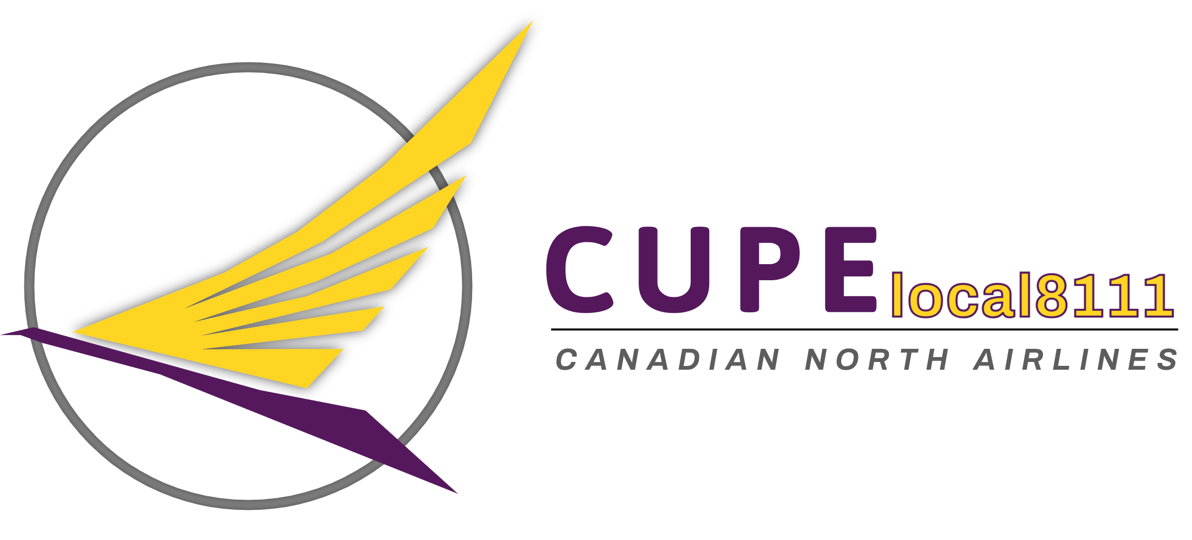

Airline Division

Division du Transport Aérien

Canadian Union of Public Employees/Syndicat canadien du la fonction publique

*Affiliated with International Transport Workers Federation/Fédération Internationale Des Ouvriers du Transport*

July 2024

Dear Local 8111 Membership, please find below the **proposed dates** for Union Management Meetings, Executive Board Meetings and General Membership Meetings.

**General Membership Meetings.**

April 13, 2024 (Virtual)

October 19, 2024 (Virtual)

**Union Management Meetings.**

January 30 2024, This was held and waiting on Company responses to our concerns

April 17, 2024 (Virtual)

June 13, 2024 (Virtual)

September 10, 2024 (In Person YOW)

**Executive Board Meetings.**

January 29, 2024 (Virtual)

February 2, 2024 (Virtual)

February 19th, 2024 (Virtual)

February 27th, 2024 (Virtual) (SMM)

March 25th, 2024 (Virtual)

April 8, 2024 (Virtual)

May 6, 2024 (Virtual)

June 10, 2024 (Virtual)

July 21st,2024 (Virtual)

September 9, 2024 (In. Person YOW)

October 21, 2024 (Virtual)

November 22, 2024 (Virtual)